**Site UI design:**

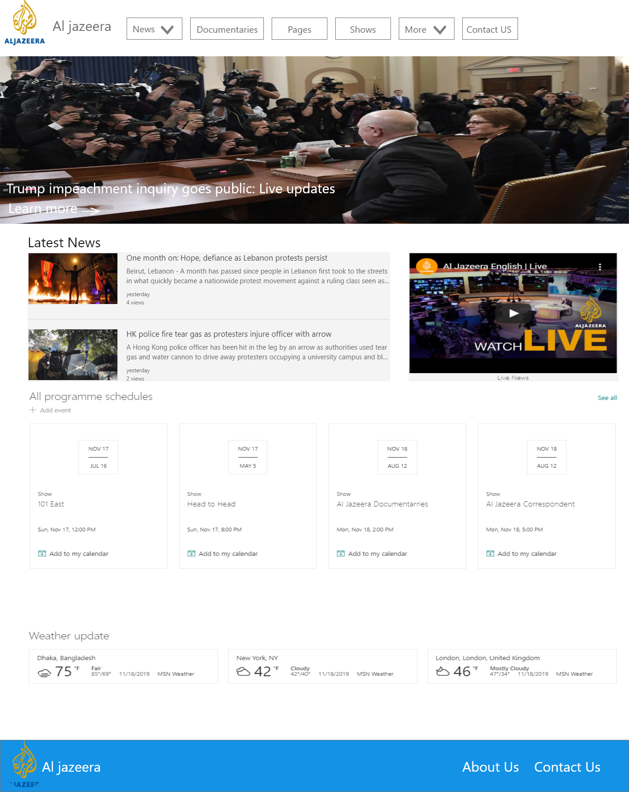

Figure 1 Home page UI design

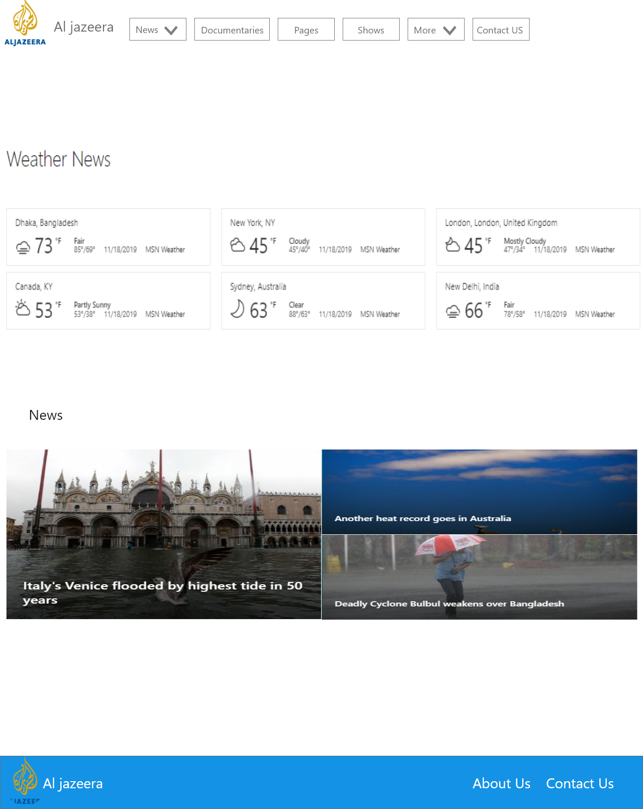

Figure 2 Weather page UI Design

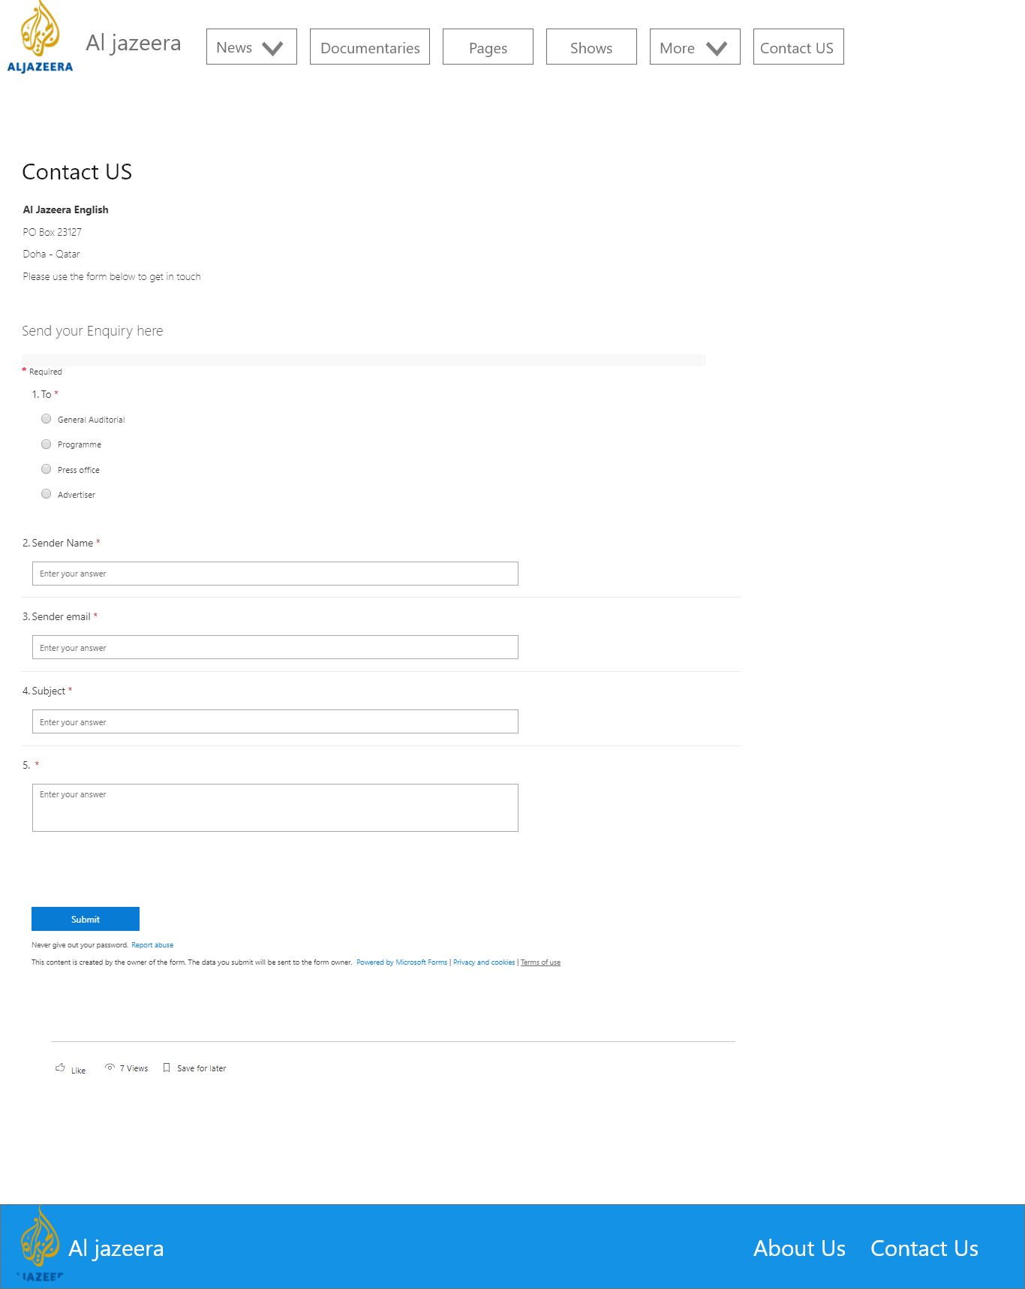

Figure 3 Contact Us UI design

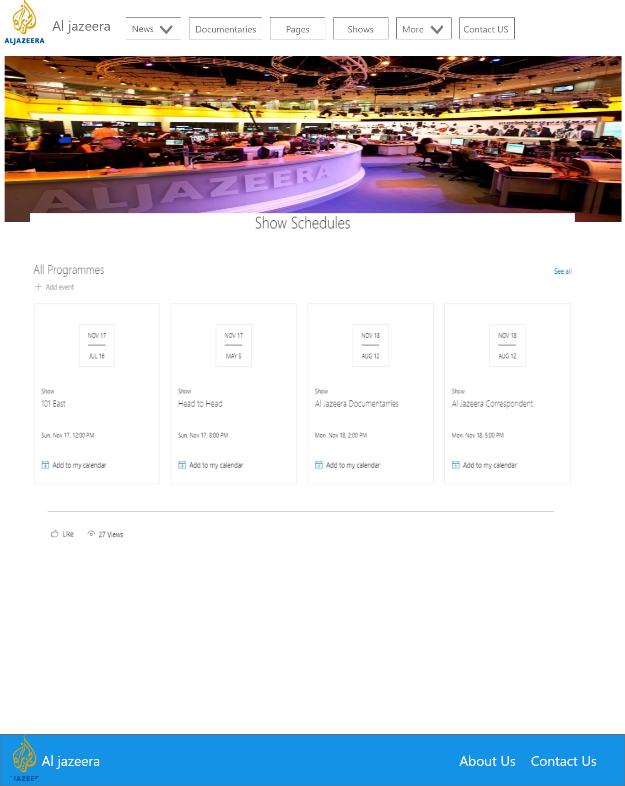

Figure 4 Schedules page UI design

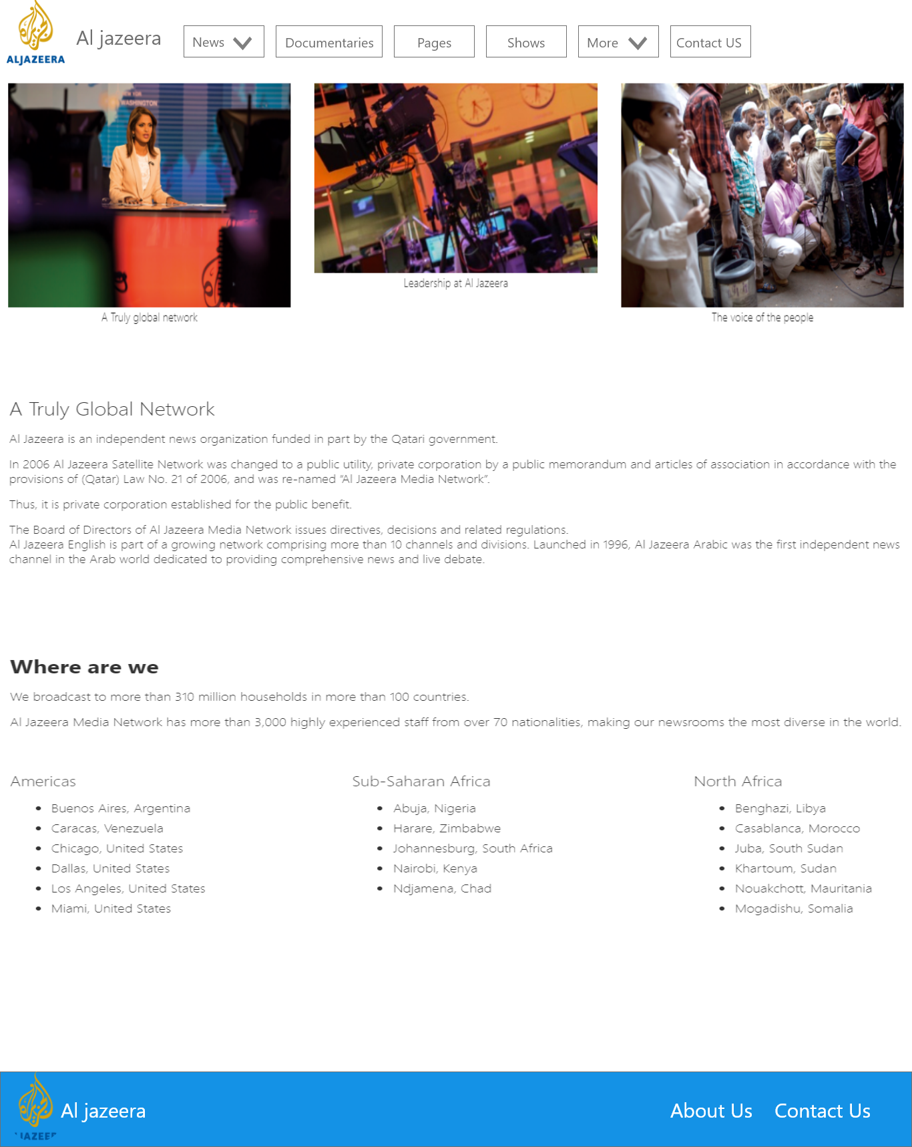

Figure 5 About Us page UI Design